Geography Knowledge Organiser:
Climate and Sustainability – What does it mean to be sustainable?
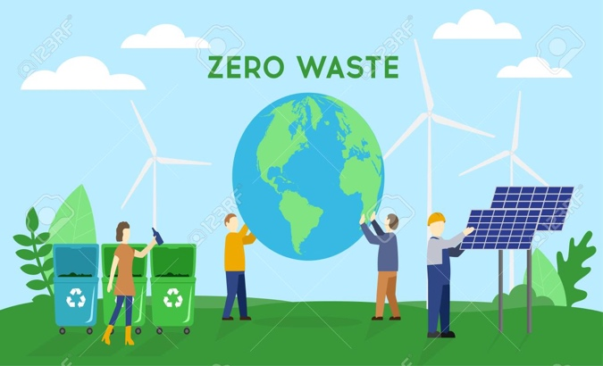
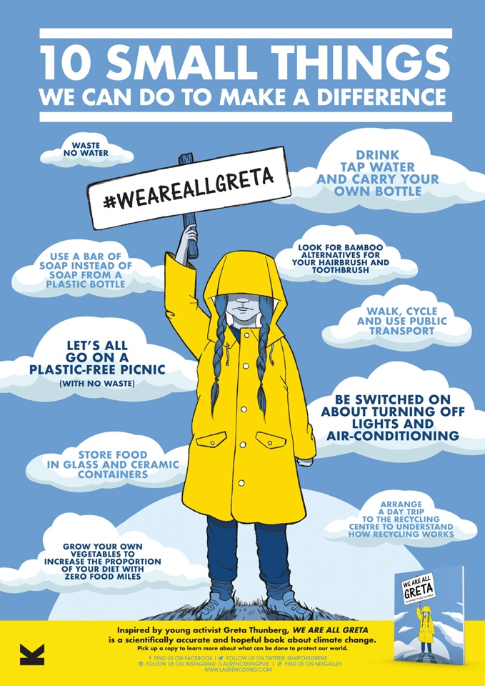
What should I already know?
- Since the earth was inhabited, humans and all other living things rely on the environment to support life.
- Humans can impact the environment in both a positive and a negative way.
- Humans require energy like electricity. This is created through collecting power from renewable or non-renewable energies.
- The UK has a lot of natural resources, including fossil fuels for energy, crops for food, and livestock for food as well as clothes.
- The differences between human features and physical features in geography.

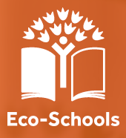
INTERESTING FACTS
- The planet naturally goes through phases of warmer and colder temperatures. This is the reason we have had ice ages!
- Enough plastic is thrown away each year to circle the earth four times.
- Plastics make up the most litter collected during international coastal clean-ups. These plastics include plastic beverage bottles, plastic bottle caps, food wrappers, plastic grocery bags, plastic lids, straws and stirrers, and foam takeaway containers.
- Energy is the number one contributor to climate change, accounting for around 60% of total global greenhouse gas emissions.

What will I know by the end of the unit?
- Sustainable energy is a form of energy which is produced in a sustainable manner.
- That energy is always being used but we can help to minimise its impact on the environment.
- That climate change will cause the remaining ice caps to melt causing sea level to rise across the world.
- That every single person has the power to change their lives to support the environment.
Key vocabulary and definitions:

Resource | Anything that is useful to people.
Renewable | A natural resource that can be easily reproduced.
Non-renewable | A natural resource which cannot be easily reproduced meaning they will run out eventually.
Sustainable | Development which meets the needs of people in the present without impacting the environment in a non-renewable way.
Development | The process of change to make people’s lives better
Fossil-fuels | Oil, coal, and natural gas are examples which formed from the remains of old plants and animals. These are difficult to retrieve and may cause damage to environment in the process.
Green energy | Energy from natural sources like the sun and sea. These have a much smaller impact on the environment.
Climate Change | The long-term alteration of temperature and typical weather patterns in a place. Climate change could refer to a particular location or the planet as a whole.
Pollution | The presence in or introduction into the environment of a substance which has harmful or poisonous effects.
Waste | Human produced rubbish which has been thrown away or recycled.

